**DISTRIBUTED IOT ENVIRONMENTAL MONITORING**

by:

**Mr F.J. Fourie**

**26047799**

**Milestone 5**

**Interim Report**

submitted in pursuit of the degree

BACHELOR OF ENGINEERING

In

COMPUTER AND ELECTRONIC ENGINEERING

North-West -University Potchefstroom Campus

Supervisor: Prof A. Helberg and Dr M Ferreira

Potchefstroom

2018

DECLARATION

I, **FJ Fourie**, declare that this report is a presentation of my own original work.

Whenever contributions of others are involved, every effort was made to indicate this clearly, with due reference to the literature.

No part of this work has been submitted in the past, or is being submitted, for a degree or examination at any other university or course.

Signed on this, 22rd day of April 2018, in Potchefstroom.

_________________________________

FJ Fourie

Table of Contents

1.1. Introduction 8

1.2. Background 8

1.3. Problem Statement 8

1.4. Envisaged Solution 9

1.1.1 Alternative Solution 9

1.1.2 Project Objectives 9

1.1.3 Project Scope 10

1.1.4 Proposed Solution 12

1.1.5 Project Testability 12

1.1.6 Project Deliverables 12

1.1.7 Project Limitations 12

1.1.8 Project Risks 12

1.1.9 Project Safety 12

1.5. Project Plan 12

1.5.1 Methodology 12

1.5.2 Work Breakdown Structure 13

1.5.3 Project Feasibility 15

1.1 15

1.2 15

1.3 15

1.4 15

1.5 15

1.5.1 15

1.5.2 15

1.5.3 15

1.6. Conclusion 18

2.1. Introduction 19

2.2. Previous Solutions 19

2.3. Air Conditioner 20

2.4. COP (Coefficient of Performance) 20

2.5. LoRa 21

2.6. Non-invasive AC Current Sensors 22

2.7. Arduino 23

2.8. Databases 24

2.9. Anemometer 25

2 Conclusion 26

Introduction 28

4.1. 28

4.2. Conceptual Design 28

3.2.1 Controller selection 28

3.2.2 Communication Selection 29

3.2.3 Database selection 30

3.2.4 Back-end programming language selection 30

3.3 Conceptual design summary 31

4.3. Conclusion 31

4 References 32

• Measure efficiency of split type air-conditioning units 35

• Communication between the sensor consoles and back-end program by way of IOT 35

• Analyse and display data 35

**Table of Figures**

Figure 1: Work Breakdown structure 13

Figure 2: LoRa Network 21

Figure 3: Arduino UNO ® pin layout 23

Figure 4: An HHF91 Anemometer that can measure CFM 25

Figure 5: High level system overview 33

**Table of Equations**

Equation 1: Relationship between current in the secondary and primary winding 21

Equation 2: CT turns Ratio calculation 22

**Table of Tables**

Table 1: High level Schedule 14

Table 2: High level Budget 16

Table 3: Controller trade-off study 27

Table 4: Communication trade-off study 28

Table 5: Database trade-off study 29

|  |  |
| --- | --- |
| TERM | DEFINITION |
| shall | Expresses a characteristic which must be present in the item of specification, thus a binding requirement |
| should | Expresses a goal or target to be pursued but not necessarily achieved |
| may | Expresses permissive guidance |
| will | Expresses a declaration of intent on the part of a party |
| STATE | The state of a system refers to a state of being of the system. |
| MODE | The mode of a system refers to the state of doing of a system. Typically modes are encapsulated within states. |

|  |  |
| --- | --- |
| Acronym | DEFINITION |
| NWU | North West University |
| Syrs | System Requirements Specification |
| tbd | To Be Defined |
| IOT | Internet of things |
| COP | Coefficient of performance |
| FSK | Frequency-shift keying |
| ISO | International Organization for Standardization |
| SANS | South African National standards |
| IEC | International Electro-technical Commission |
| LORA | Long range wide area network |
| GUI | Graphical user interface |
| IP | Ingress Protection |

|  |  |
| --- | --- |
| ABBREVIATION | EXPLANATION |
| e.g. | For example |
| REQID | Requirement Identifier |
| IR | Infrared |
| $$mm$$ | Millimetre |
| $$mA$$ | Milliampere |
| $$μA$$ | Microampere |
| $$V$$ | Voltage |

Chapter 1 – Introduction

## Introduction

There is currently a large number of split type air-conditioning units used in large commercial buildings. Most entities that manage these buildings deal with split type air-conditioning units in one of two ways. They either replace them after they have functioned for a predetermined period [1] or after the air-conditioning unit has stopped functioning. This is inconvenient, inefficient, cost intensive and has a negative ecological impact.

Currently there is no efficiency monitoring system commercially available for the split type air-conditioning units. Keeping ineffective split type air-conditioning units in operation results in wasted electricity, with the resultant increased electricity costs. This impacts on the profitability of a business.

The aim of this project is to optimise the use of split type air conditioning in industrial and commercial settings. The project is intended real time onscreen efficient measurements for each air conditioning unit.

## Background

During this project a significant aspect of the problem is that there is no reliable way to determine and know the coefficient of performance (COP) of a split type air-conditioning unit. This has the consequence that air conditioning units are left to operate even after they have become much less efficient than they are supposed to be and vice versa meaning air conditioning units are replaced before it is truly necessary. This results in a loss of energy and capital for the company. Through the implementation of a system that monitors the COP there can also be some bonuses such as predictive maintenance. In this project the problem will be solved by making use of IOT sensors that will be fitted to existing installed split unit air conditioners. These sensors will be able to send data over the internet so that the COP of any air conditioning unit can be calculated at any time. The data will be used to enable the prediction of when a unit needs to be repaired or serviced.

## Problem Statement

There is currently a considerable number of split type air-conditioning units used in large commercial buildings. Most companies that own these buildings handle these split type air-conditioning units in one of two ways. They either replace them after they have reached a predetermined age [1] or they wait for the air-conditioning unit to break. This leads to a loss of capital and unnecessary wasting of electricity. Electricity is wasted by keeping ineffective split type air-conditioning units in operation. The loss in capital comes from an unnecessary high electricity bill and the wrongful replacement of split type air-conditioning units. This is a problem and a method by which the performance of the air-conditioning unit is used to determine when it needs to be replaced is necessary.

The aim of the project is to develop a low cost IOT sensor that can be installed and used with all currently operational split air-conditioner units in commercial properties. The sensor consoles must be cost efficient in terms that the amount that is saved due to the application of the sensor consoles is more than the cost of the sensor console itself. The sensor console should be capable of calculating the COP of any of the split air-conditioner units at any time. The sensor consoles should record data to send over the internet to a central computer that will interpret and analyse the data in order to gauge the overall condition of a split air-conditioner unit.

The central computer needs to be able to use the received data from the sensors to determine when an air-conditioner unit needs to be repaired or serviced. Predictive maintenance should be made possible by making use of IOT. Predictive maintenance is done by using algorithms to predict when a split type air-conditioner unit is going to break. This should allow the system to automatically call maintenance personnel to the site of the split type air-conditioner unit that is predicted to break. A user friendly GUI (Graphical User Interface) is necessary to make the central computer easy to use and understand for the operator. This enables him to check desired information more easily and effectively. There also needs to be a user friendly method to see which split type air-conditioning units need to be repaired or serviced.

## Envisaged Solution



### Alternative Solution

For the Distributed IOT Environmental monitoring project it is explicitly stated in the client student agreement of he project scope that the Distributed IOT Environmental Monitoring system must be applied to split type air-conditioning units. Therefore, there is no existing alternative solution for the monitoring of the split type air-conditioning units. At present the only other solution is to use a split type air-conditioning unit until it breaks or replacing and servicing the split type air-conditioning units on a predetermined schedule.

### Project Objectives

All the necessary individual components such as sensors and transmitters necessary for this project already exist. These devices are within budget of the project, therefore it will be low cost to build and implement the device in the existing split type air-conditioning units. The low cost in combination with already existing technology availability and the low impact the device will make in the budget makes it technologically feasible. This project is designed in order that it can be implemented in a wide variety of buildings with a wide variety of infrastructure making it an ideal device for mass manufacturing and implementation. The project won’t be invasive and because the project will help conserve electricity it is socially applauded and supported thus making the project socially feasible.

The benefits and objectives of this project is to:

• Save funds by stopping the unnecessary replacement of air conditioning units

• Save electricity by identifying faulty and inefficient air conditioning units

• Replacing the split type air-conditioning unit before it breaks down

The project will stop the unnecessary wasting of capital that occur during the unnecessary replacement of air-conditioning units. This will be done by monitoring and calculating the coefficient of performance of every air conditioning unit, this will allow the system to tell you the appropriate time is to replace the unit.

The project will also save electricity by informing the operator when an air conditioning unit is no longer working efficiently and needs to be serviced or replaced. This will be done by measuring and keeping track of the performance of all the units as to enable the identification of a unit that shows abnormal behaviour.

Increased office comfort will be a by-product of this project but should not be overlooked, as a comfortable work space facilitates higher productivity and happier employees. This will be done by the identification of air conditioning units showing abnormal behaviour as stated above and then by servicing or replacing them you will stop them from actually breaking down and leaving an employee to work in a non-air-conditioned office.

### Project Scope

The scope of the project is to design a more cost effective and non-invasive sensor console with a central computer program that the sensor console can communicate with. The sensor console needs to have temperature sensors connected to it that will be used to measure the intake air temperature as well as the output air temperature. A current sensor will be connected to the sensor console and the power supply of the split type air-conditioning unit in order to calculate the input power and to monitor when the split type air-conditioning unit is on. The sensor console is required to be connected to IOT in order to transmit data. LoRa will be used to transmit data from the sensor console. LoRa will be used due to the relative inexpensiveness of the necessary LoRa module as well as its relative long range and low power usage. A central computer is necessary that can communicate with all the sensor consoles in that particular building. This central computer will be used to access the sensor consoles and to gather data from them and interpret the data into valuable information. The central computer needs a GUI to enable an operator to access all the information.

The objectives of this project is the design and building of the sensor console and the programming of the back end program that will run on the central computer. This project must make it possible to determine when to service and repair a split type air-conditioning unit based on its COP.

The approach that will be used in solving the problem is:

* Identifying, analysing and understanding the problem
* Exploring and researching possible solutions to the problem
* Identify a solution to the problem then specify and describe the solution
* Design the system that will be used and then create a detailed design of it
* Build the system
* Test the system
* Improve the system and finalize it

For this project the sensor consoles and the back end program is within scope. The gateway and the cloud is not within scope. This means that the transmission between the sensor consoles and the back end program is within scope but that the network it is transmitted over is not within scope.

### Proposed Solution

### Project Testability

The following aspects must be verified in order to prove that the Distributed IOT Environmental monitoring project’s prototype accomplishes the objectives stated in section 1.4.2. Project objectives.

* The Distributed IOT Environmental Measuring system should gather data from a split type air-conditioning unit and transfer the data to a given point.
* The system should be capable of getting a basic approximation of the performance of a split type air-conditioning unit, transfer it using IOT to a back-end program and display the data.
* The data should then be processed into information and displayed in a program that neatly and functionally shows the information to the operator.

### Project Deliverables

The Distributed IOT Environmental Monitoring project has certain deliverables that are to be present at the close of the project, namely:

* A sensor device to gather data from the split type air-conditioning unit.
* Data transition from the sensor to the back-end program using IOT.
* Basic approximation of the performance of the split type air-conditioning unit.
* Program displaying information to the operator.

### Project Limitations

Certain limitations were set for the project, namely:

* The project should be completed within the parameter of the set budget of R 2 500.
* The project should be completed before 15 November 2018.
* The device must be installable in a preinstalled split type air-conditioning unit.

### Project Safety

## Project Plan

As part of the project plan the methodology, work breakdown structure and project feasibility is discussed below.



### Methodology

The engineering design process is followed as part of the methodology for this project to successfully complete the Distributed IOT Environmental Monitoring project.

* The first step in the engineering design process is problem identification and analysis. To ensure correct problem identification an agreement on specification of the problem scope between the client and student is undertaken.
* The next step is to conduct research on existing solutions for the identified problem as well as the available resources. Therefore the all possible solution for the problem are considered.
* A complete literature study of all the aspects regarding the project, this ensures a thorough understanding of the different parts of the project. It is of utmost importance to choose the correct technology for the Distributed IOT Environmental Monitoring project. The main components to be decided on for the Distributed IOT Environmental Monitoring are:
  + Communication device
  + Controller device to be used
  + Database to store and process the data.
* Next a concept design is done of the proposed solution. In the concept design a trade-off study is done for the different components based on cost, reliability, availability and development difficulty.
* From the trade-off studies a detailed design of the proposed solution is done. In the detail design all the chosen components for the trade-off studies are provided.
* Once the detail design is complete the prototype can be constructed. The prototype must then be tested to ensure everything functions as planned.
* Next the subsystems can be constructed and integrated to form the proposed solution.
* This is followed by testing of integrated system to ensure all the subsystems integrated correctly. Final testing of the complete Distributed IOT Environmental Monitoring system must be done to test whether the product functions as set out in the requirements document for the project.
* During all phases of the project documentation of all work is done. The documentation will act as proof that the engineering design process was followed.

### Work Breakdown Structure

The following Figure 1 shows the work breakdown structure for the Distributed IOT Environmental Monitoring project. The figure shows what is within scope for this project and what is outside scope also shows some of the levels of the project.

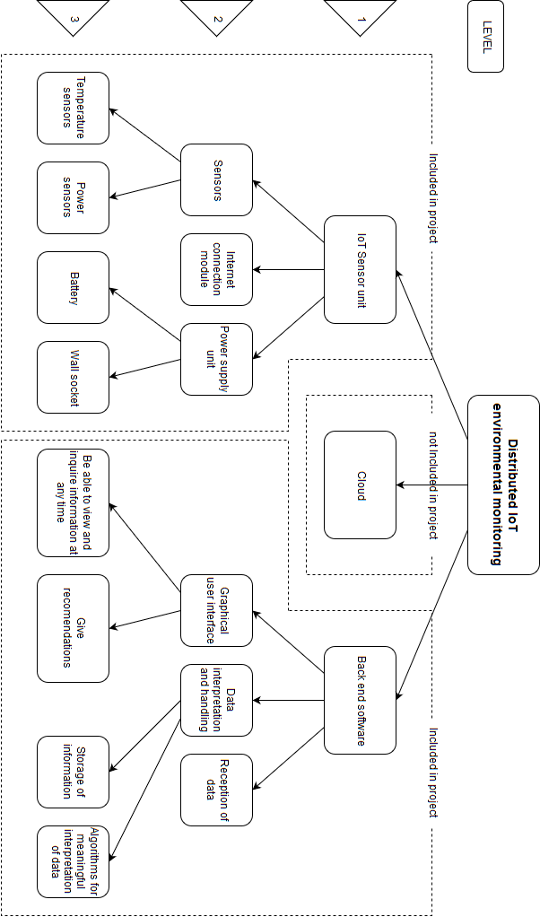

Figure 1: Work Breakdown structure

### Project Feasibility

Factors such as the availability, budget, resources, complexity and schedule of the project greatly influence the feasibility of a project. These aspects of the Distributed IOT Environmental Monitoring project is discussed.



#### Schedule

In below Table 1 the high level schedule is shown which may be subject to change and any change in schedule will be documented.

Table 1: High level Schedule

|  |  |
| --- | --- |
| Date | Task Description |
| 05-02-2018 | University term begins |
| 07-02-2018 | Schedule meeting with project manager |
| 09-02-2018 | Prepare for oral problem contextualisation |
| 12-02-2018 | Project Milestone 1: Problem Contextualisation Oral |
| 14-02-2018 | Meeting with project manager |
| 19-02-2018 | Project Milestone 2: Problem Identification and Analysis Proposal document |
| 07-03-2018 | Determine possible solutions |
| 12-03-2018 | Project Milestone 3: Evaluation of possible solutions document |
| 14-03-2018 | Determine design specifications |
| 19-03-2018 | Project Milestone 4: Specification document 2 |
| 21-03-2018 | Start design of IOT sensor unit system |
| 28-03-2018 | Start design of system for back end software |
| 20-04-2018 | Complete system design |
| 23-04-2018 | Project Milestone 5: System Design document |
| 24-04-2018 | Start working on detail design |
| 26-05-2018 | Complete detail design for IOT sensor unit and back end software |
| 28-05-2018 | Project Milestone 6: Detail Design document |
| 19-05-2018 | Isolate core aspect of project |
| 20-05-2018 | Implement core aspect of design |
| 18-06-2018 | Project Milestone 7: Implementation & Evaluation: Core Demo |
| 18-07-2018 | Project Milestone 8: Implementation & Evaluation: Functional Demo |
| 19-07-2018 | Correct faulty components of project |
| 20-07-2018 | Start working on integration of project |
| 17-08-2018 | Complete integration IOT sensor unit through the cloud with the back end software |
| 20-08-2018 | Project Milestone 9: Implementation & Evaluation: Integrated Demo |
| 01-10-2018 | Prepare for performance evaluation |
| 15-10-2018 | Project Milestone 10: Implementation & Evaluation: Performance Evaluation Demo |
| 18-10-2018 | Finish simplified report for Milestone 11 |
| 19-10-2018 | Project Milestone 11: Project at a Glance |
| 26-10-2018 | Complete project report |
| 29-10-2018 | Project Milestone 12: Final Report Submission |
| 30-10-2018 | Create poster for project |
| 02-11-2018 | Project Milestone 13: Poster Submission |
| 06-11-2018 | Prepare for oral examination |
| 07-11-2018 | Project Milestone 14: Oral Exam |
| 07-11-2018 | Close Project |

#### Budget

In the below Table 2 the preliminary budget is shown that may be changed once detail design is done and project specification is finalised.

Table 2: Preliminary Budget

|  |  |  |
| --- | --- | --- |
| Component Name | Price | Quantity |
| Lora RF Transceiver Module | R 120,00 | 5 |
| Temperature sensor | R 25,00 | 10 |
| Non-invasive current sensor | R 70,00 | 5 |
| Arduino Nano V3.0 | R 50,00 | 5 |
| Total | R 1450,00 |  |

#### Resources

During the development of the Distributed IOT Environmental Monitoring project the following resources will used:

* Human Resources

The following human resources are available for the project:

Prof. A. Helberg - Project Manager

Dr M Ferreira - Project Manager

Mr FJ Fourie - Engineering student

* Software Resources

Software resources will be used for documentation and simulation of the design for the project as well as for the database used in the project:

* + Microsoft Word ®
  + Microsoft Excel ®
  + MySQL ®
  + C++ ®
  + C ®
* Funds

For the Distributed IOT Environmental Monitoring project R 2500 is allocated by the NWU to complete the project.

#### Risks

The main risks of the project is the difficulty to measure the efficiency of split type air-conditioning units. This is due to the difficulty in measuring the output energy of the split type-air-conditioning unit. The Anemometer could measure this output however an anemometer is outside the budget of the Distributed IOT Environmental Monitor, and therefor also too expensive to feasibly improve the split type air-conditioning unit. Time presents another risk in this project, however with proper planning the risk can be mitigated.

## Conclusion

Chapter 1 of this document acts as an introduction to the Distributed IOT Environmental Monitoring project. In this project a monitoring system should be designed that can be installed in a preinstalled split type air-conditioning unit. This monitoring system should be able to approximate the productivity of the split type air-conditioning unit by analysing data measured with its sensors. The data should be transmitted to a back-end program where the data will be processed and then displayed with a neat, easy to use program to the operator.

In this chapter the project process is presented by providing the proof of planning, as can be seen in the planned schedule, budget, resources and risk review. This combined with the methodology of the project, that is the engineering process supports the well-ordered process of the project.

In this chapter a basic conceptual design is given for the Distributed IOT Environmental Monitoring project. There are currently no commercially available alternative solutions for split type air-conditioner unit productivity monitoring. This chapter provides the scope and objectives set for the Distributed IOT Environmental Monitoring project. The conceptual design aspects are discussed in chapter two below, where a literature study was done on each aspect of the design.

Chapter 2 – Literature Study



## Introduction

The Distributed IOT Environmental Monitoring project is about the lack of a reliable, more cost effective method with which the COP (Coefficient of Performance) of an already installed split type air-conditioning unit can be monitored. This has the consequence that air conditioning units are kept in operation despite performing less efficient than expected. On the opposite end of the spectrum air conditioning units are replaced before it becomes a liability due to poor performance and therefore replacement becomes necessary. This results in loss of energy and capital for the company. In this project the problem will be attempted to be solved by making use of IOT (Internet of Things) sensors. These IOT sensors will be fitted to existing installed split unit air-conditioners thereby making it a more cost effective solution. These IOT sensors will be able to send data via the internet in order to calculate the COP of any air-conditioning unit at any given time. The data collected from the IOT sensors will be used to enable an estimation of when a unit needs to be repaired or serviced.

The literature study for the Distributed IOT Environmental Monitoring project is listed here in Chapter 2. A short overview of the problem will be presented in the problem statement section of the report below. The problem statement explains and substantiates the relevance of the project. A project overview briefly describes what will be done during the project and how it will be done to complete this project to satisfaction. The project scope is also included in the report. This shows what is included and what is excluded from the project, thereby giving a clear picture of what must be addressed in the project. The importance of this project will be addressed by identifying the unique aspects of the project as well as referring to the shortcomings of already existing solutions and why they are not applicable to this particular problem. This all will be followed by a complete in depth literature survey that will look at all existing documentation and research on the different aspects of the project. Research on different possible solutions of the different aspects presented by the project will be performed. In an attempt to identify the most applicable solution, for each aspect of the project.

## Previous Solutions

There is no commercially available system that can be permanently installed on already operational split type air-conditioning units to monitor their COP. Currently deciding when to replace split type air-conditioning units is based on either their age or when they break.

According to the official Energy Star website [2] it is time to replace your air conditioner when it is 10 years old or when the air conditioner needs frequent repairs and your energy bill starts going up. An article on Angie’s List [3] also collaborates this stating that you should consider replacing your air conditioner if it is more than 10 years old. The article on Angie’s List [3] also gives frequent repairs as the other way to know when to replace your split type air-conditioning unit.

## Air Conditioner

The principle of an air conditioner is removing heat from one area and replacing it with cold air. The five main components of most air conditioners are as follows [4]:

* Compressor
* Condenser
* Evaporator Coil
* Blower
* Chemical refrigerant

Split type air-conditioning units consist of an outdoor unit that includes the compressor, condenser, expansion valve and a fan. Then the indoor unit comprises a cooling fan and the cooling coil or evaporator [5].

The split type air-conditioning units works by activating the outdoor compressor which starts to circulate the refrigerant gas. This circulation of the gas increases its temperature since it is compressed through a series of pipes. The refrigerant then moves to the condenser where a cooling system removes heat from the gas which then turns the gas into a chilled liquid. The chilled liquid is then transferred to the indoor evaporator. At the evaporator a fan collects warm air that is then passed through the chamber which contains the chilled liquid refrigerant. When the air leaves the chamber it is cooled and is blown back into the room by means of the fan. This process is repeated until the split type air-conditioning unit’s thermostat detects the correct temperature has been reached at which point the unit will switch off.

## COP (Coefficient of Performance)

The COP of a system is the measure of that systems amount of output power compared to the amount of input power:

|  |  |  |
| --- | --- | --- |
|  | $$COP= \frac{power output}{power input}$$ | (1) |

The COP is a good indication of the efficiency of a split air-conditioner unit as it is independent of external variables, as can be seen in Equation (1) above. Other advantages of the COP are that it is instantaneous therefore it can be calculated at any point in time as power is measured is Watt [6]. Carnot’s theorem expresses the theoretical maximum COP for an air conditioning system [7]. Carnot’s theorem can be reduced to Equation (2):

|  |  |  |
| --- | --- | --- |
|  | $${COP}_{maximum}=\frac{T_{C}}{T_{H}-T_{C}}$$ | (2) |

In Equation (2) $T_{C}$ represents cold temperature and $T_{H}$ represents the hot temperature and both must be in Kelvin. In order to convert Celsius (°C) to Kelvin add 273.15 to the Celsius value. When using Equation (2) for space cooling the temperature inside the space will be the cold temperature and when using Equation (2) for space heating the cold temperature will be the outside temperature.

## LoRa

LoRa is a wireless technology that is power efficient and enables low data rate communication over long distances. The key features of the LoRa wireless system are the following [8]:

* Long range: 15 – 20 km
* Millions of nodes
* Long battery life: in excess of ten years

LoRa is perfect for Internet of Things as it has the features necessary for IOT. These requirements include secure bi-directional communication, mobility and localization abilities [9]. LoRaWAN is a LPWAN (Low Power Wide Area Network) specification. LoRaWAN network architecture is usually a star topology that makes use of gateways as a transparent bridge to relay messages between the central network server and the end devices. The communication between the end devices and the gateways are spread between different data rates and frequency channels.

There are three main classes of end point devices which is [9]:

* Bi-directional end-devices (Class A)
* Bi-directional end-devices with scheduled receive slots (Class B)
* Bi-directional end-devices with maximal receive slots (Class C)

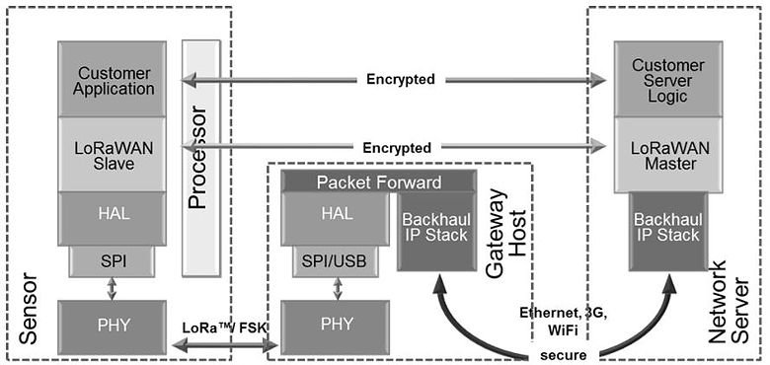

Figure 2: LoRa Network

In Figure 2 The structure of communication using LoRa is shown. The Sensor in Figure 2 communicates with the gateway that is connected to the internet so that the data can be send to the Network Server.

## Non-invasive AC Current Sensors

None-invasive AC Current Sensors are used to measure the real consumption without having to alter the electrical composition of circuit. The sensors work by acting as an inductor that responds to a magnetic field around a current carrying conductor. By making use of the following equations the sensor can determine the current in the current carrying conductor [10]:

|  |  |  |
| --- | --- | --- |
|  | $$I_{secondary}= {CT}_{turnsRatio} × I_{primary}$$ | (3) |

Equation 1: Relationship between current in the secondary and primary winding

As well as the CT turns Ratio calculation in equation (4).

|  |  |  |
| --- | --- | --- |
|  | $${CT}_{turnsRatio}= \frac{{Turns}_{primary}}{{Turns}_{secondary}}$$ | (4) |

Equation 2: CT turns Ratio calculation

In

|  |  |  |
| --- | --- | --- |
|  | $$I_{secondary}= {CT}_{turnsRatio} × I_{primary}$$ | (3) |

Equation 1 the relationship between the current in the secondary winding circuit ($I_{secondary}$) and the current in the primary winding circuit ($I_{primary}$) is given.

|  |  |  |
| --- | --- | --- |
|  | $${CT}_{turnsRatio}= \frac{{Turns}_{primary}}{{Turns}_{secondary}}$$ | (4) |

Equation 2 shows the Current transformers turn ratio (${CT}_{turnsRatio}$) in terms of the relationship between the number of turns in the primary (${Turns}_{primary}$) CT (Current Transformer) and the number of turns in the secondary (${Turns}_{secondary}$) CT.

## Arduino

Arduino is an open source platform that is used for electronic projects due to its ease of use. Arduino consists mainly of two parts the physical programmable circuit board as well as the IDE (Integrated Development Environment) that is used to write and upload code to the board. Advantages of Arduino is as follows [11]:

* Lower cost than other similar devices
* Cross-platform
* Simple, clear programming environment
* Open source and extensible software
* Open source and extensible hardware

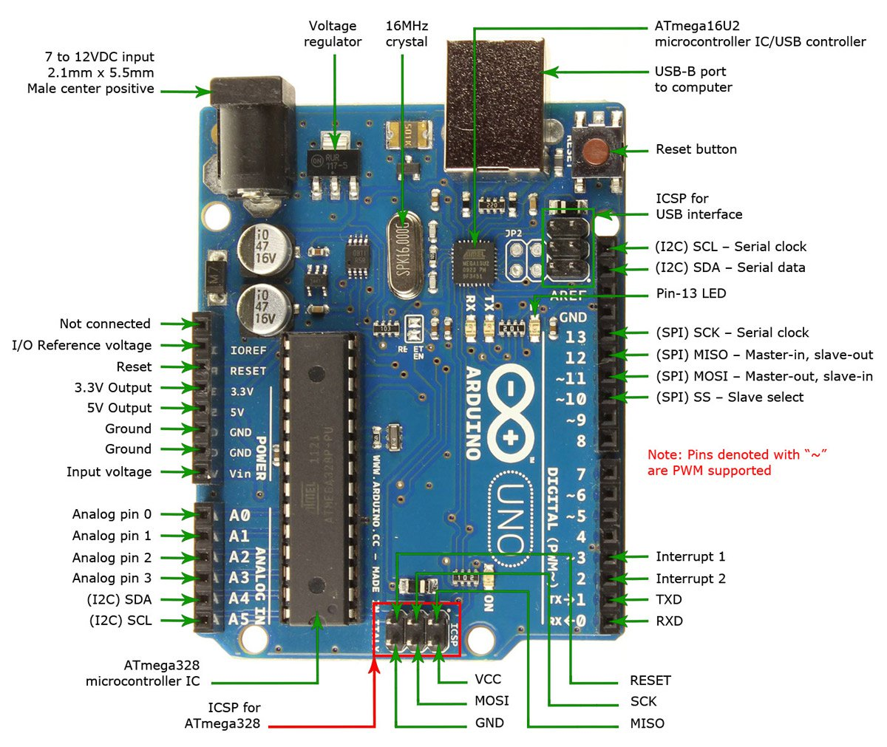

Figure 3: Arduino UNO ® pin layout

In Figure 3 an Arduino UNO ® is shown with its pin descriptions. Arduino® uses a simplified version of C++® making it easy to program for anyone with knowledge in programming C®. Due to the popularity of the Arduino® they are easy to integrate and use with other components as there already exist libraries for a lot of components. There is an abundance of support online as well for the Arduino® making it easy troubleshoot and find help if needed. There is a wide range of different Arduino® boards and expansion modules making it easy to find the appropriate combination of components for your application. Arduino® is readily available in South Africa at a reasonably low cost making it an ideal development board use for a project.

## Databases

There are a two main database servers that can be considered for this project, they are MariaDB® and MYSQL®. Both these database servers are open source and free to use. They also both use SQL (Structured Query Language) which is an easy to use and well documented programming language with a lot of support available online. These database servers both use a broad subset of ANSI SQL 99 [12]. These reasons made these two database servers the obvious choices for the project. The server of both is ‘mysqld’ and the command-line client is ‘mysql’ with the configuration file being ‘my.cnf’. This means that both MySQL and MariaDB are compatible with each other [13]. The disadvantage of MariaDB is that MariaDB releases tend to lack behind MYSQL releases because the MariaDB developers need to merge the newly released MYSQL code into the MariaDB source trees. Advantages of the MariaDB software is that it has some added features, bug fixes, additional storage engines and performance improvements over MYSQL.

## Anemometer

Anemometers are used to measure the speed or velocity of wind and other gasses. There are a wide variety of different types which are listed below [14]:

* Vane Anemometers
* Thermal Anemometers
* Thermal Anemometers with velocity / Temperature Profiling
* Cup Anemometers

The two main classifications of anemometers are constant-temperature anemometers and constant-power anemometers. Advantages of constant-temperature anemometers are their high-frequency response, immunity from sensor burnout if airflow drops rapidly, electronic noise levels are low and they can be applied to both liquid or gas flows.

It is difficult to implement anemometers in integrated circuits because of their relative large size in comparison with other sensors such as temperature sensors. They are also quite expensive in comparison with other sensors. An anemometer that can measure CFM (Cubic Feet per Minute) can have dimensions: 181 x 70 x 35 mm (71⁄8 x 2¾ x 13⁄8") (handheld); 73 mm (27⁄8") diameter fan [15]. The anemometer costs R 3200.00. This makes such an anemometer not practical to be used in this project.

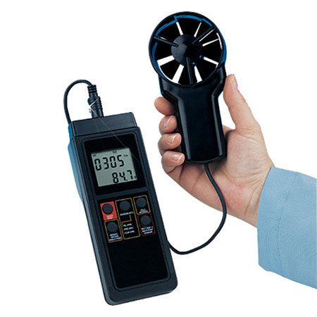

Figure 4: An HHF91 Anemometer that can measure CFM

In Figure 4 The HHF91 anemometer is shown that can measure CFM, the dimensions and cost is described above.

# Conclusion

In this report a definition of the project was given showing what is included in the project and what is excluded. From the research it is clear that there is no commercially available solution that offers a COP calculation to determine at which point a split type air-conditioning unit needs to be repaired or has reached the end of its life cycle. At the moment the most common solution for repairing and replacing split type air-conditioning units is by replacing them after 10 years or once they have gone through multiple repairs. The project overview section gave some detail on what methods will be used and how they will be used to complete the project.

The major obstacle the project faces is the calculation of output power from the split type air-conditioning units. There is no existing solution to easily and effectively determine the output power of the split type air-conditioning unit at any point in time.

The main focus of this report was the literature survey. The literature survey was done on the COP, LoRa, Non-invasive AC Current Sensors, Air Conditioner, Arduino, databases and the anemometer. These are all core components of the project. This project was researched in detail to ensure an in-depth level of comprehension of all these aspects and components and their working.

Chapter 3 – Design



## Introduction

The literature study that was done helped identify possible technologies that could be used to complete this project. For the conceptual design trade-off studies where used to determine which technologies will be used above others. How these technologies will be implemented and used are not given in the conceptual design section. The detail design will contain that will be done later will state how the chosen technologies will be implemented and used.



## Conceptual Design

For the conceptual design trade-off study’s is used to decide what technology’s will be used for the project. Trade-off studies helps the developer to make rational and accurate decisions between different technologies.



### Controller selection

Three different possible controllers for the sensor console where identified. These controllers are compared below in Table 3. As can be seen a PIC microcontroller is the most suitable for this project but considering an Arduino is so easy to use for development it will be used to develop the project before a PIC is used in the final project.

Table 3: Controller trade-off study

|  |  |  |  |  |  |  |  |
| --- | --- | --- | --- | --- | --- | --- | --- |
| Controller | | Arduino Uno | | Raspberry Pi | | PIC Microcontroller | |
| Criterion | **Weight (W)** | **Rating (R)** | **W x R** | **Rating (R)** | **W x R** | **Rating (R)** | **W x R** |
| Cost | 0.3 | 7 | 2.1 | 4 | 1.2 | 10 | 3 |
| Reliability | 0.3 | 8 | 2.4 | 6 | 1.8 | 9 | 2.7 |
| Available help material | 0.2 | 9 | 1.8 | 7 | 1.4 | 9 | 1.8 |
| Development Difficulty | 0.2 | 10 | 2 | 8 | 1.6 | 5 | 1 |
| Total Rating |  |  | 8.3 |  | 6 |  | 8.5 |

### Communication Selection

For the communication medium the two possible options that where considered is shown and compared below in Table 4. LoRa is chosen because of its main advantage over Sigfox being that you don’t need a subscription.

Table 4: Communication trade-off study

|  |  |  |  |  |  |
| --- | --- | --- | --- | --- | --- |
| Controller | | LoRa | | Sigfox | |
| Criterion | **Weight (W)** | **Rating (R)** | **W x R** | **Rating (R)** | **W x R** |
| Cost | 0.3 | 10 | 3 | 6 | 1.8 |
| Implementation Difficulty | 0.3 | 9 | 2.7 | 7 | 2.1 |
| Availability of help documentation | 0.2 | 8 | 1.6 | 7 | 1.4 |
| Power consumption | 0.2 | 9 | 1.8 | 8 | 1.6 |
| Total Rating |  |  | 9.1 |  | 6.9 |

### Database selection

The different databases that where considered for this project is compared and shown below in Table 5. The main advantage of the MYSQL is the easy to use software for the development of the database.

Table 5: Database trade-off study

|  |  |  |  |  |  |
| --- | --- | --- | --- | --- | --- |
| Controller | | MYSQL | | MariaDB | |
| Criterion | **Weight (W)** | **Rating (R)** | **W x R** | **Rating (R)** | **W x R** |
| Cost | 0.3 | 10 | 3 | 10 | 3 |
| Knowledge of language | 0.3 | 9 | 2.7 | 9 | 2.7 |
| Availability of help documentation | 0.2 | 9 | 1.8 | 7 | 1.4 |
| Implementation Difficulty | 0.2 | 9 | 1.8 | 8 | 1.6 |
| Total Rating |  |  | 9.3 |  | 8.7 |

### Back-end programming language selection

Different programming languages that could be used for the back-end program is compared below in Table 5.

Table 6: Back-end programming language selection matrix

|  |  |  |  |  |  |  |  |
| --- | --- | --- | --- | --- | --- | --- | --- |
| Programing language | | C++ | | C | | Python | |
| Criterion | **Weight (W)** | **Rating (R)** | **W x R** | **Rating (R)** | **W x R** | **Rating (R)** | **W x R** |
| Functionality | 0.3 | 9 | 2.7 | 7 | 2.1 | 5 | 1.5 |
| Development Difficulty | 0.3 | 9 | 2.7 | 7 | 2.1 | 10 | 3 |
| Available help material | 0.2 | 9 | 1.8 | 10 | 2 | 7 | 1.4 |
| Knowledge of language | 0.2 | 9 | 1.8 | 8 | 1.6 | 6 | 1.2 |
| Total Rating |  |  | 9 |  | 7.8 |  | 7.1 |

## Conceptual design summary

The following is the results of the trade-off studies showing which technologies where chosen.

* Controller: PIC Microcontroller
* Communication: LoRa
* Database: MYSQL
* Back-end: C++

## Conclusion

The literature study that was done helped identify possible solutions for the aspects of this project. These possible solutions where then further evaluated and compared against each other in the conceptual design. Trade-off studies where used to compare the different possibilities with each other and give clear indications of which will be the best options. With the correct technologies now identified the process to create the detail design can start.

# References

|  |  |
| --- | --- |
| [1] | Green Building Council South Africa, “GREENOVATE ENGINEERING,” Growthpoint Properties, Joahnnesburg, 2018. |
| [2] | ENERGY STAR, “When is it time to replace?,” 29 September 2017. [Online]. Available: https://www.energystar.gov/index.cfm?c=heat_cool.pr_checklist_consumers. [Accessed 10 March 2018]. |
| [3] | S. Price, “When Is It Time to Replace My Air Conditioner?,” 25 July 2015. [Online]. Available: https://www.angieslist.com/articles/when-it-time-replace-my-air-conditioner.htm. [Accessed 10 March 2018]. |
| [4] | The Air Conditioning Company, “How Does Air Conditioning Work,” 8 October 2016. [Online]. Available: https://www.airconco.com/how-does-air-conditioning-work/. [Accessed 10 March 2018]. |
| [5] | H. Khemani and L. Stonecypher, “Types of Air Conditioning Systems,” 1 January 2013. [Online]. Available: https://www.brighthubengineering.com/hvac/897-types-of-air-conditioning-systems/. [Accessed 10 March 2018]. |
| [6] | Power Knot, “COPs, EERs, and SEERs How Efficient is Your Air Conditioning System?,” Power Knot LLC, Milpitas, 2011. |
| [7] | S. Qian, Y. Geng, Y. Wang, J. Ling, Y. Hwang, R. Radermacher, I. Takeuchi and J. Cui, “A review of elastocaloric cooling:,” *international journal of r e f r i g e r a t i o n,* vol. I, no. 64, pp. 1 - 19, 2016. |
| [8] | I. Poole, “LoRa Wireless for M2M & IoT,” 15 July 2017. [Online]. Available: http://www.radio-electronics.com/info/wireless/lora/basics-tutorial.php. [Accessed 10 March 2018]. |
| [9] | LoRa Alliance, “LoRa Alliance Technology,” 17 February 2017. [Online]. Available: https://www.lora-alliance.org/technology. [Accessed 10 March 2018]. |
| [10] | G. Hudson, “CT sensors - An Introduction,” 11 January 2017. [Online]. Available: https://learn.openenergymonitor.org/electricity-monitoring/ct-sensors/introduction?redirected=true. [Accessed 10 March 2018]. |
| [11] | Arduino, “What is Arduino?,” 27 November 2017. [Online]. Available: https://www.arduino.cc/en/Guide/Introduction. [Accessed 10 March 2018]. |
| [12] | M. Sarig, “MariaDB vs MySQL: In-Depth Comparison,” 28 March 2017. [Online]. Available: https://blog.panoply.io/a-comparative-vmariadb-vs-mysql. [Accessed 11 March 2018]. |
| [13] | D. Bartholomew, “MariaDB vs. MySQL,” 9 June 2016. [Online]. Available: http://www.admin-magazine.com/Articles/MariaDB-vs.-MySQL. [Accessed 11 March 2018]. |
| [14] | OMEGA Engineering, “Anemometer: Introduction to Air Velocity Measurement,” Spectris , 6 February 2015. [Online]. Available: https://www.omega.com/prodinfo/anemometers.html. [Accessed 11 March 2018]. |
| [15] | OMEGA Engineering, “Volume-IndIcatIng thermo-anemometer KIt,” Spectris, Stamford, 2018. |

Appendix A: URS

1. Introduction

The document appendix gives a definition of the requirements of the Distributed IOT Environmental Monitoring project.

1. Engineering Problem Definition
2. Envisaged Solution

The item that will be developed is a sensor console to monitor the split type air-conditioning unit as well as a back-end program to provide the measurements to the client. The sensor console will interact with the existing split type air-conditioning unit as well the existing IOT gateway. A back-end program will be developed that will interact with the existing gateway.

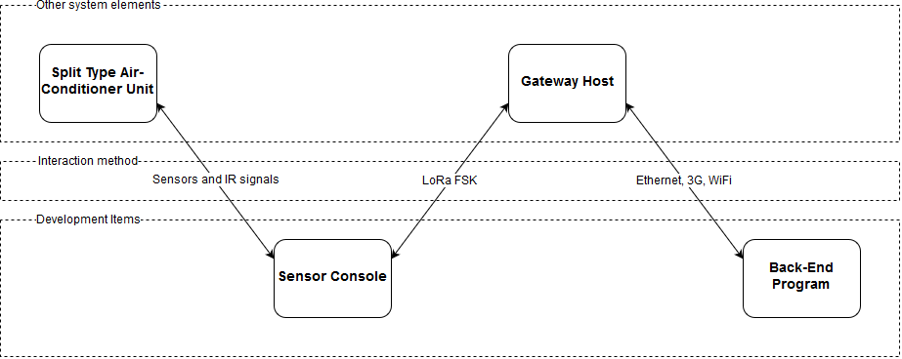

Figure 5: High level system overview

In Figure 5 the system overview reflects what will be developed and how it will interact with the already existing systems. There will be monitoring and communication between the already existing split type air-conditioning units and the developed sensor consoles by means of sensors and IR signals. The developed sensor consoles will send and receive data to and from an already existing gateway host by means of LoRa. Finally, the back-end program that will be developed will communicate with the existing gateway host in order to receive and send data to and from the sensor consoles.

1. Requirements
   1. Physical Requirements

The sensor consoles shall be easily wall mountable so not heavier than 1 kg and not larger than 100 mm x 200 mm. REQID 0015

The sensor console shall be a single easy to handle unit for this reason it needs to be in an enclosure. REQID 0016

The housing of the unit shall adequately protect the sensor console, therefore the housing shall have a IP rating of at least IP 31. REQID 0017

* 1. Performance Requirements

### Measure efficiency of split type air-conditioning units

The system shall provide an indication of efficiency of split type air-conditioning units at agreed upon intervals. REQID 0001

### Communication between the sensor consoles and back-end program by way of IOT

The sensor consoles need to be able to send and receive data to and from the back-end program by making use of LoRa. REQID 0002

### Analyse and display data

Analyse the data received from the sensor consoles and display pertinent information to the operator inside a GUI. REQID 0003

* 1. Intended Operating Environment

The sensor consoles will be installed directly adjacent to the split type air-conditioning units. REQID 0007

The sensor console will not be exposed to ambient temperature outside operational ranges as specified on data sheets of -20 ⁰C to 60 ⁰C. REQID 0008

The sensor console will be near single phase electrical power plug to draw power from. The power outlet needs to supply 220-240 V at 50 Hz and be able to deliver 0.1 A. REQID 0009

1. Limitations

The limitations of this project is the size of the Distributed IOT Environmental Monitoring device, it must be small enough to be placed in the Split type air-conditioning unit. Another limitation of the project is that the Distributed IOT Environmental Monitoring device must be installed in an already installed split type air-conditioning unit. This limits the solutions for the Distributed IOT Environmental Monitoring project extensively.

1. Acceptance criteria

* If the system cannot gather data from a split type air-conditioning unit and transfer the data to a point a mark of <40% (fail) shall be awarded.
* If the system is capable of getting a basic approximation of the performance of a split type air-conditioning unit and can transfer it using IOT to a back-end program and display the data a mark of 60% would be in order.
* If an accurate approximation the performance of a split type air-conditioning unit can be determined and it can be transferred over IOT and displayed on a back-end program a mark of 70% would be fair.
* If the system can accurately approximate the performance of a split type air-conditioning unit and can then transmit the data over IOT where the data is then processed into information and displayed in a program that neatly and functionally shows the information to the operator. This will result in a mark of 75%+ where all additional value adding functionality and features will result in increased marks